





**Direct and Inverse Proportions**

1. If two quantities are related such that a change in one causes a corresponding change in the other, then we say that one varies with the other.

There are two type of variations/ proportions:

* 1. Direct variation/ proportion
  2. Indirect variation/ proportion

# Direct proportion:

* 1. Two quantities x and y are said to be in direct proportion if whenever the value of x increases (or

decreases), then the value of y increases (or decreases) in such a way that the ratio x

y

remains

constant.

Example: Cost is directly proportional to the number of articles, Work done is directly proportional to the number of men working on it.

* 1. When x and y are in direct proportion, we have:

x1 etc.

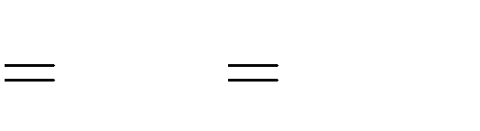

x2 x3 ,

y2 y3

y1

Here, y1, y2, y3, … are the values of y corresponding to the values x1, x2, x3, … of x.

# Inverse Proportion:

* 1. Two quantities x and y are said to be indirect proportion if whenever the value of x increases (or decreases), then the value of y decreases (or increases) in such a way that xy remains constant.

Example: The time taken to finish a work is inversely proportional to the number of persons working at it, The time taken by any vehicle in covering a certain distance is inversely proportional to the speed of the car.

* 1. When x and y are in inverse proportion, then x1 y1 = x2 y2 = x3 y3, and so on.

Here, y1, y2, y3, … are the values of y corresponding to the values x1, x2, x3, … of x.

1. Map is a miniature representation of a large regions. Hence we can say that scale of a map is based on the concept of direct variation.

The scale shows a relationship between actual

length and the length represented on the map. Thus, it is the ratio of the distance between two points on the map to the actual distance between two points on the large region.

1. Suppose A can finish a piece of work in n days. Then, work done by A in 1 day = 1 .

n

1. When a person A completes work.

 1 th

 

n

 

part of the work in one day, then A will take n days to complete the

1. In a cistern there are two pipes. The inlet is the pipe that fills the cistern and the outlet is the pipe that empties the cistern.
2. When an inlet fills the cistern in ‘n’ hours, then it will fill up 1 th part of the cistern in one hour.

n

1. When an outlet empties the cistern in ‘n’ hours, then it will empty out 1 th part of the cistern in one

n

hour.

1. Multiplicative inverse of a number is called the reciprocal of a number.